Financial Services Coalition – Puget Sound

ANNUAL REPORT 2007

Building the Coalition…One Member at a Time

May 31, 2008

President’s Letter
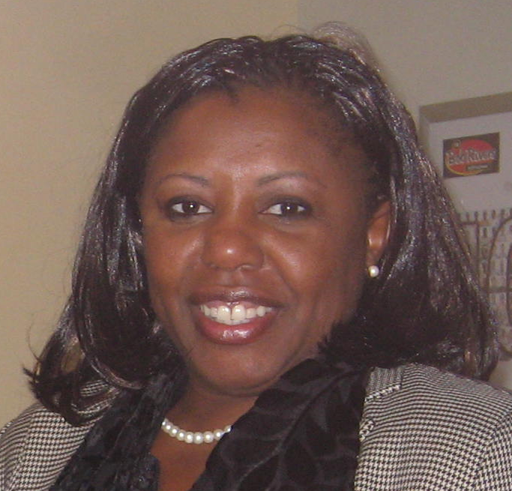
Congratulations FSC-PS Team! We weathered the storm. As typical with most startup organizations, we experienced the bumps and bruises that are just part of growing pains. We effectively formed the FSC-PS organization on October 25, 2007. We formed with three outstanding officers (Vice President Ajay Grewal, Treasurer Li Ying Wang, and Webmaster Cheung Vong) whom volunteered their free time after working hours and on weekends and finally taking the plunge into uncertainty. Lizzie L. Evans
I applaud your dedication and commitment
and I truly believe your passion is contagious
and will spread throughout the new year.

The FSC-PS is a non profit volunteer organization with the primary mission of servicing its members. As a non-profit volunteer organization, we also seek to do some good works in the community. Whether conducting first-time home buyer programs, credit awareness to high schools, individual taxation, mock interviewing workshops, retirement planning, or small business seminars; FSC-PS aims to spread financial education and promote asset building in the underrepresented communities throughout the Puget Sound counties. The objectives of the FSC-PS are:

- To bring together minority professionals in the financial services industry for the exchange of experiences, ideas and interests in order to help promote career and professional development;

- To acquaint professionals with the opportunities available in the financial services industry;

- To provide educational, technical and advisory assistance to the underserved communities in the Greater Puget Sound counties; and

- To promote financial education by improving financial literacy to new immigrants and into the unbanked and underserved communities.

Our kickoff meeting was held on May 14, 2007 at the personal residence of President Lizzie L. Evans. There were only two people present. Former President and CEO Andrew Ghim of Unibank and yours truly, Lizzie L. Evans. We quickly recognized the need to produce mass recruitment strategies.
The next meeting was held on June 27, 2007 at the Federal Deposit Insurance Corporation’s downtown Seattle Office. Ms. Lisa Kanemoto of the FDIC Community Affairs division in San Francisco presented the audience a brief overview of the FDIC Money Smart modules. The topic generated 10 people and a consensus for a future Money Smart train-the-trainer workshop during 2008 was formed.

Over the course of the next few months, our interest group gained momentum. UFSC National President L. Diane Evans attended our August 30, 2007 meeting which was hosted by Unibank in Lynwood, WA. It was during this general meeting that the UFSC officially recognized the Interest Group. The group brainstormed the basic make up of the Puget Sound communities and its needs. The following objectives are recapped:

- Mentoring with entry-level professionals (One-on-One Coaching, Sounding Boards, and Shadowing Opportunities)
- Providing YMCA membership to low income families (No Child Left Behind) in partnership with YMCA
- Physical and financial mentoring and tutoring to underprivileged children
- Addressing the unbanked and underserved communities (micro lending and other banking services/products)
- Reaching out to the military personnel by promoting financial literacy
- Raising credit awareness to young adults
- Cross-Discipline Forums
- Technology Outreach to Small Businesses
- Seminars to host Emerging Financial Services Issues
- Expand Networking Opportunities

Regal Financial Bank and United Commercial Bank quickly jumped on board and garnered support for their employees by hosting the September and October general meetings with light refreshments. Western Regional Representative James Jackson called in on a few meeting to offer support and chapter formation guidance. The required ByLaws and other organizational and structural documents were prepared and reviewed by the National Parliamentarian Christy Bryant.

President Lizzie L. Evans attended the UFSC Regional Business Meeting in Los Angeles, CA during November 2 – 3, 2007. At this meeting, the concept of having two separate entities, a 501 C 3 and a 501 C 6, was explained and encouraged by the UFSC Chapter Development Chair Brenda Joseph in order to promote fundraising activities. The interest group was acknowledged again by UFSC National President L. Diane Evans. An idea such as the Featured Member of the Month was endorsed by the UFSC members in attendance.

On November 29, 2007, we held a meeting with Treehouse as guest speaker to introduce the tutoring, coaching-to-college, and wearhouse programs. We initiated a fundraiser “Parkas for Treehouse” with plans to raise $25,000 for Treehouse enhancement programs. The public service announcement was broadcasted on five local radio stations. With very little credibility and community awareness, we fell very short of the goal but managed to raise $1,550 by year-end 2007. As a result, the nominal fundraiser developed a strategic alliance with Treehouse and gave birth to our first partnership.

2007 Financial Performance Reports
As of December 31, 2007

Profit & Loss

Ordinary Income/Expenses
Income
Membership Dues 680.00
Uncategorized Income *1,550.00
___________
Total Income 2,230.00

Expense
Other Mis. Expenses .10
Supplies and Materials 117.61
___________
Total Expenses 117.71

Net Ordinary Income 2,112.29

Net Income 2,112.29

Balance Sheet

Asset
Current Asset
Checking/Savings 1,432.29
Other Current Assets 680.00
___________
Total Assets 2,112.29

Liability & Equity
Equity 2,112.29

Total Liability & Equity 2,112.29

* Profit and Loss statement shows our net income is $2,112.29, Uncategorized income $1,550 reflects our first fund raiser for “Treehouse” in 2007, our net income from membership dues for 2007 is $680

The above financial statements have been prepared in a accordance with GAAP without audit or independent review by Treasurer Li Ying Wang.

Strategic Outlook for 2008

1st Quarter
- Complete Parkas for Treehouse Donation Drive
- Conduct Membership Drive
- Conduct Two Community Development Seminars
- Produce and distribute first Quarterly Newsletter

2nd Quarter
- Seminars for Chapter Members (FDIC Money Smart)
- Web site backup training and blogging
- Implement a Student Internship Program
- 1st Annual Scholarship and Awards Dinner
- Hold Annual General Meeting to develop Business Plan, Approve Budget, Ratify ByLaws, and Strategies for Membership Drives and Developing Partners/Alliances, Distribute Annual Report
- Participate in the Annual National UFSC Conference
- Promote Treehouse Tutoring Training Session
- Partner with local organization to conduct mock interview and resume writing workshops
- Election Results
- Super Recruiter Announcement

3rd Quarter
- Board Turnover Dinner Meeting and Retreat
- Establish Project Lead for Black History Month Program
- Build strategic alliance with local community based organizations
- Apply for operating grants
- Assign Web page ownership for blogging
- Promote Treehouse Tutoring and Coaching-to-College Workshops
- Establish shadowing opportunities at a bank (BEAM)
- Cvent Training (Membership, Event, Web based Tracking Tool)
- Develop Credit Awareness Program for the three most underserved High Schools in King County
- Develop In-House Adult Financial Literacy Curriculum and target audiences for next year’s Financial Literacy Month

4th Quarter
- Parkas for Treehouse Donation Drive – Hosted by the Foundation
- Roll out Cvent
- Develop 2 new scholarship programs
- Establish Project Lead for 2nd Annual Scholarships and Awards Dinner
- Membership Drive
- Holiday Gathering

2007 Directors and Officers

President – Lizzie L. Evans
Vice President – Ajay Grewal
Treasurer – Li Ying Wang
Webmaster – Cheung Vong

2007 Members in Good Standing

Wayne Smulan
Janet Cheung
Peter Park
DC Grant
Gwen Allen-Carston
Melissa Johnson

